Curriculum vitae (CV)
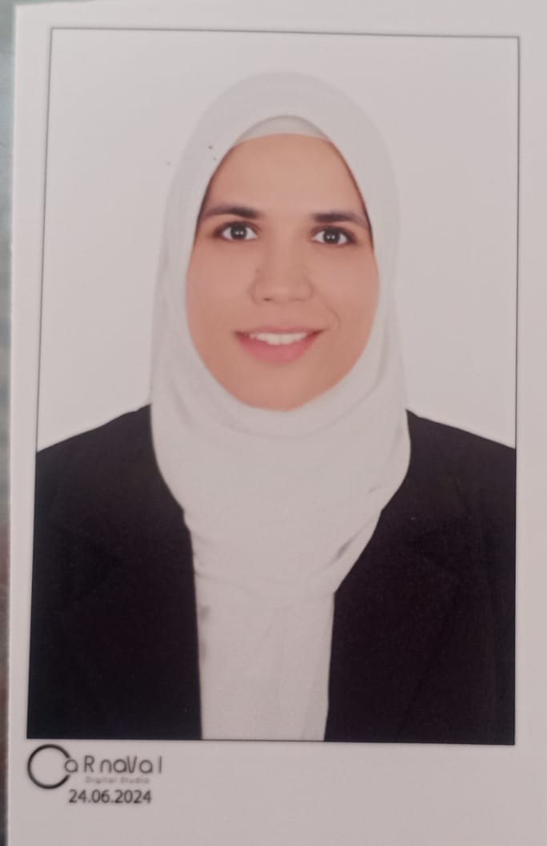
Alaa Abd Elaziz Elsayed
Personal details:
Name: Alaa Abd Elaziz Elsayed
Date of birth: 26 August 2000.
Place of birth: Kafr aldawar, Egypt.
Nationality: Egyptian.
Address: Kafr aldawar City, El Behira Government, Egypt.
Mobile: +2 01212954393.
Email: a.basiouny00344@vetmed.dmu.edu.eg
Qualifications:
Bachelor's Degree of Veterinary Sciences (BVS, May 2023): Damanhur University, Faculty of Veterinary Medicine, Egypt.
Current job:
Demonstrator of physiology at Faculty of Veterinary Medicine, Damanhur University from 24/6/2024.
Training programs:
- Scientific Research Ethics and Methods, September 2024.

Languages
1. Mother language: Arabic
2. English: fluent
Computer skills:
- Expert in using office programs like word, power point and excel.
professional skills:
- Assisting in teaching practical sessions for undergraduate students.
- Contribute to research activities in the field of physiology.

