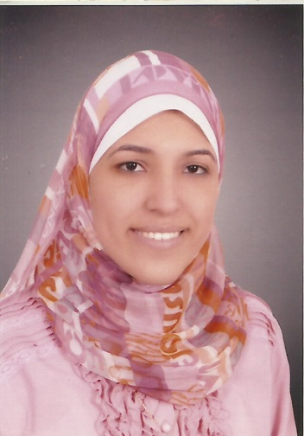
Amira Emad Mahmoud ElNahas

Personal information
Date of Birth: 16/12/1988
Place of Birth: Alexandria, Egypt
Address: Ebad ElRahman tower, El Sayed Atteya Street off El Tayar Sabry Street- Bab Shark- Alexandria.
CEP: +201115780448 and +0201008832275
Telephone: +2-03-3811713.
E-mail: amira.emad@pharm.dmu.edu.eg
amiraemadelnahas@yahoo.com

Academic degree
- Bachelor of Pharmaceutical Sciences, July 2011, Excellent, Honor, Faculty of Pharmacy, Alexandria University, Alexandria, Egypt.
- Master in Pharmaceutical sciences, June 2017, Excellent, Honor, Faculty of Pharmacy, Alexandria University, Alexandria, Egypt.

Employment and Academic History
Sep. 2011 to present: demonstrator of pharmaceutics, Faculty of Pharmacy, Damanhour University, Damanhour, Egypt.
June. 2017 to present: assistant lecturer of pharmaceutics, Faculty of Pharmacy, Damanhour University, Damanhour, Egypt.

Teaching Experience
Undergraduate practical courses:
- Physical pharmacy.
- Industrial pharmacy.
- Biopharmaceutics.
- Pharmaceutical quality control.
- Liquid dosage forms.
- Solid dosage forms.
- Semi-solid dosage forms.
Technical Experience
- Nanoparticles formulation and evaluation.
- Conducting various solid dosage forms quality control testing.
- Analytical methods development and validation.
- Cytotoxicity studies using different techniques: histological and biochemical methods.

Publications and posters
- El-Nahas AE, Allam AN, Abdelmonsif DA, and El-Kamel AH. Silymarin-Loaded Eudragit Nanoparticles: Formulation, Characterization, and Hepatoprotective and Toxicity Evaluation. AAPS PharmSciTech (# 2017) DOI: 10.1208/s12249-017-0799-9.
- Amira E. El-Nahas, Ahmed N. Allam & Amal H. El-Kamel (2017): Mucoadhesive buccal tablets containing silymarin Eudragit-loaded nanoparticles: formulation, characterisation and ex vivo permeation, Journal of Microencapsulation, DOI: 10.1080/02652048.2017.1345996.
- Poster abstract in 3rd FUE International Conference of Pharmaceutical Sciences (3rd FUE-ICPS 2015), held on 9-11 February, 2015 at Intercontinental-city Star, Cairo, Egypt. "Preparation and physico-chemical characterization of silymarin–Eudragit loaded nanoparticles", Amira E. El-Nahas, Ahmed N. Allam, Amal H. El-Kamel.
Participation in Conferences
- The Bio Vision Alexandria 2016, April-12-14, 2016, Bibliotheca Alexandria, Alexandria, Egypt.
- The 3rd FUE International Conference of Pharmaceutical Sciences (3rd FUE-ICPS), February-9-11, 2015, Intercontinental City Stars Hotel, Nasr City, Cairo, Egypt [Poster presentation].
- The Bio Vision Alexandria 2014, April-7-9, 2014, Bibliotheca Alexandria, Alexandria, Egypt.
- The first annual faculty research day, February 22, 2014, Faculty of pharmacy, Alexandria University, Alexandria, Egypt.

Courses Attendance
- "Effective presentation skills" training course, July 4-5, 2016, Faculty and leadership development center, Alexandria, Egypt.
- "Research methods" training course, june 29-30, 2015, Faculty and leadership development center, Alexandria, Egypt.
- "Research Ethics" training course, December 15-16, 2014, Faculty and leadership development center, Alexandria, Egypt.
- "Quality standards in teaching" training course, September 1-2, 2014, Faculty and leadership development center, Alexandria, Egypt.
- "International publishing of research" training course, July 25-26, 2012, Faculty and leadership development center, Alexandria, Egypt.
- "Clinical practice for pharmacist" training course, February 12-22, 2011, Faculty of pharmacy, Alexandria University, Alexandria, Egypt.
- Summer training at Al Amrya pharmaceuticals, August 29 – September 2, 2010, Alexandria, Egypt.
- "Patient counseling" training course, February 17-22, 2009, Egyptian center for human development, Alexandria, Egypt.
- "Pharmaceutical selling skills" training course, July-August 2008, Alexandria, Egypt.
Skills
• Foreign languages: English [Band 8, IELTS].
• Advanced computer skills [International Computer Driving License (ICDL)].

